NEWS TRACKER APPLICATION

|  |  |
| --- | --- |
| Date | 27 September 2022 |
| Team Members | Bhuvaneshwaran.S, Ashwin.M, Mohan Kumar.K Ragul Rathna.T |
|  | PNT2022TMID24438 |
| Project Name | NEWS TRACKER APPLICATION |
| Maximum Marks | 2 Marks |

Customer Problem Statement:

* A traveler who wants to know the updated news of every place which he wants to visit instantly about the cost, weather, new places, our app will give him the up-to date news of all the details which he require to travel without any disturbances.
* A guy who is into new technologies would like to know daily updates on new launches of computers and other electronic gadgets , this is where our application will help him to get daily details of launches of different devices by different brands to full fill his requirements.

# working at its hard to

get it

in bus stop there is no

bus

snke

police officer

## he is very

hard to find

# he is too smart

post officer its very

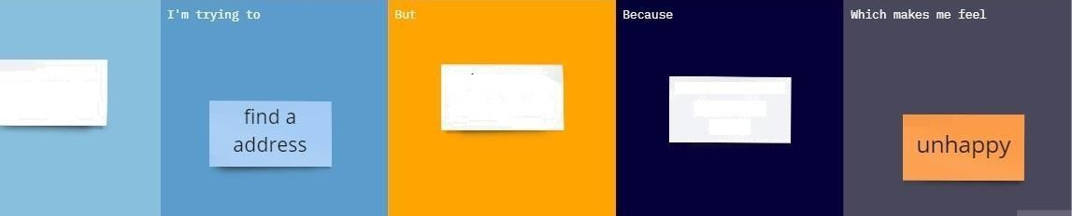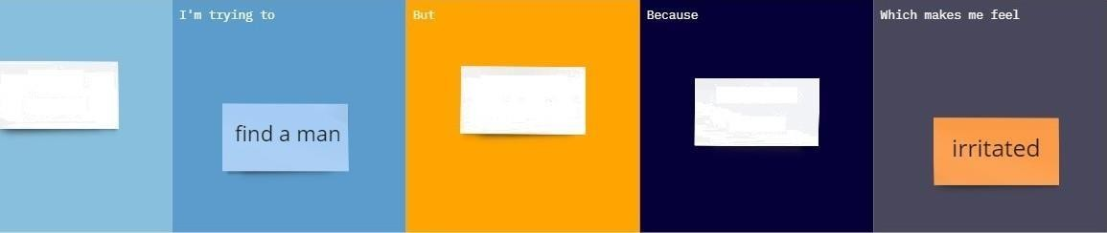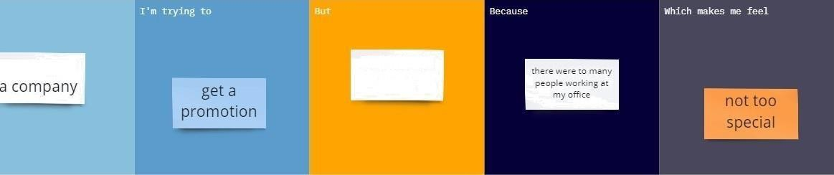

# hard to find

that address is to deep in the village